|  |
| --- |
|  |
| Fotoball |
|  |
| CSC509: Sequence Diagram |

April 6, 2015  
Authored by: David Cipoletta, AbrAhAm Herrera, Adam Jilling, Rick Rejeleene

Version: 1.2

April 5, 2015

Authored by: David Cipoletta, AbrAhAm Herrera, Adam Jilling, Rick Rejeleene

Rev 1.2

Fotoball

CSC509: Sequence Diagram

Contents

Sequence Flow Diagram 2

Database Diagram 3

Hardware Sequence 4

Use Case 6

### Sequence Flow Diagram

The following chart represents the flow of control through the software system. All videos will be saved to the internal media gallery of the parent device.

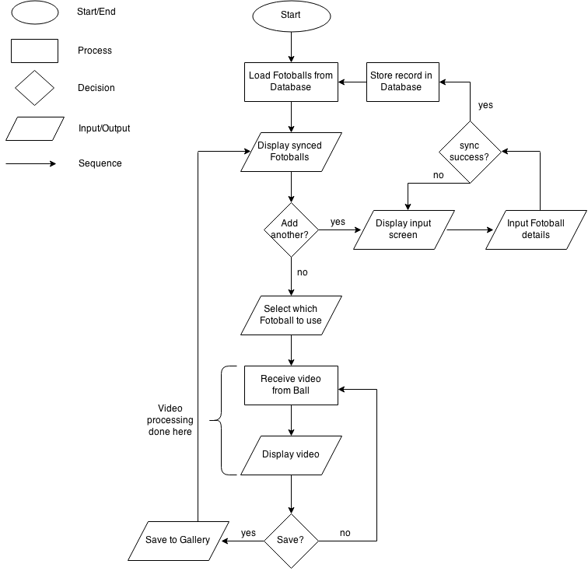

### Database Diagram

The database will connect the ball information with the mobile application. Anywhere from zero to n balls will be allowed to be created and the time and date of each creation will stored, as well as the relevant ball information.

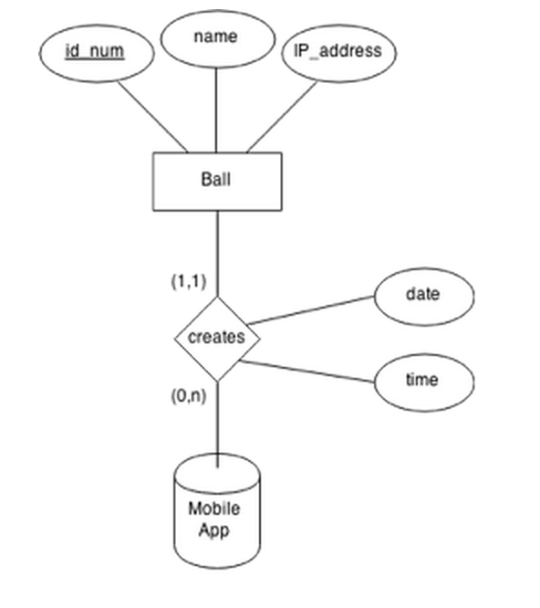

### 

### Hardware Sequence

This represents the sequence of flow from the hardware system’s perspective. Cameras will be switched manually via hardware.

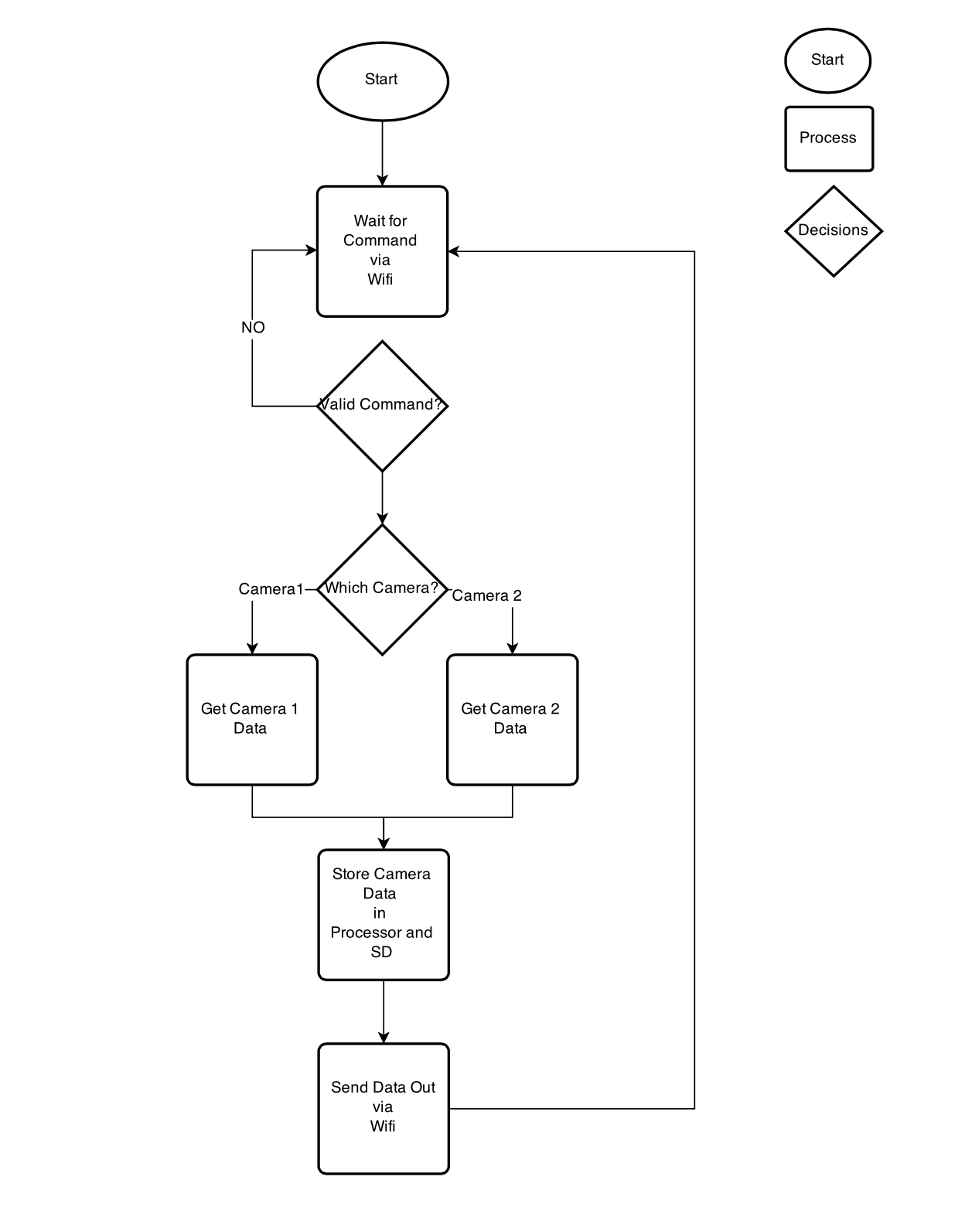

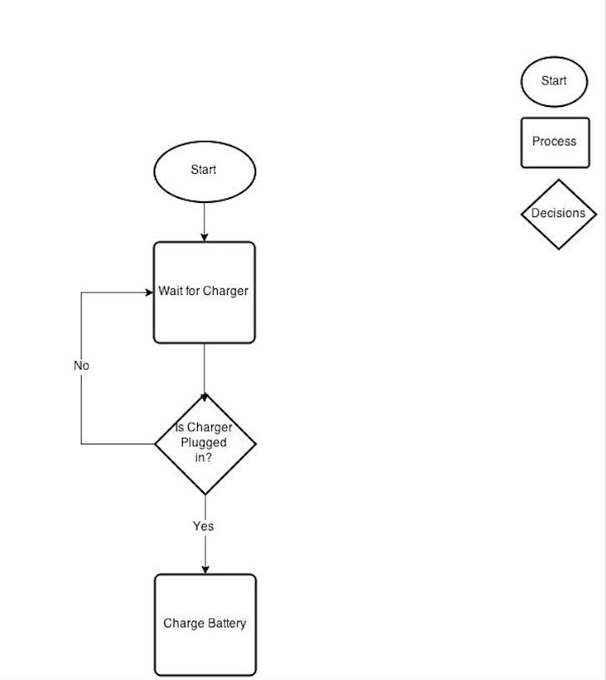

### Use Case

This App shows the user interaction with the user and the football

Use Case 1: User checking a new Fotoball

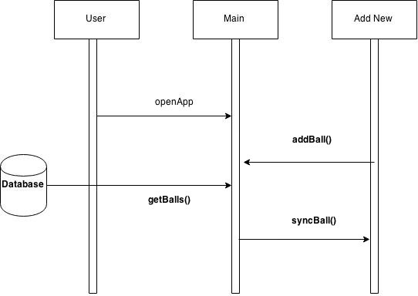

Use Case 2: User checking a live stream from the list of sync'ed Fotoball streams and save it on his personal device

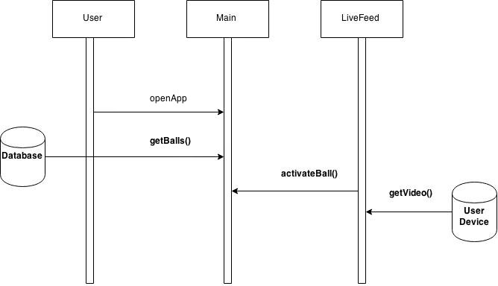

Use Case 3: User checking a new Fotoball and selecting a live stream

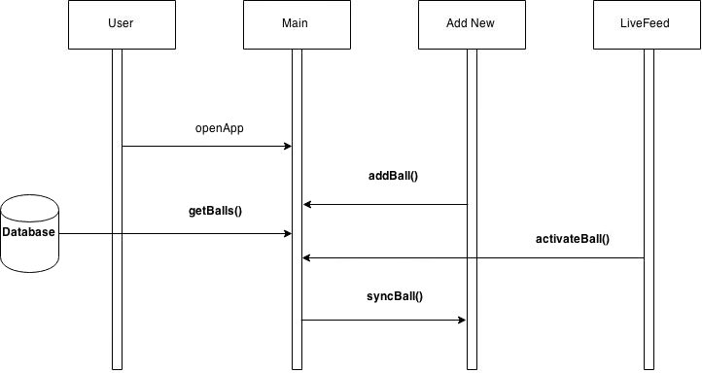

Use Case 4: User checking the About information

